22. Develop a system using UML for Online Insurance Processing System.

Class diagram:

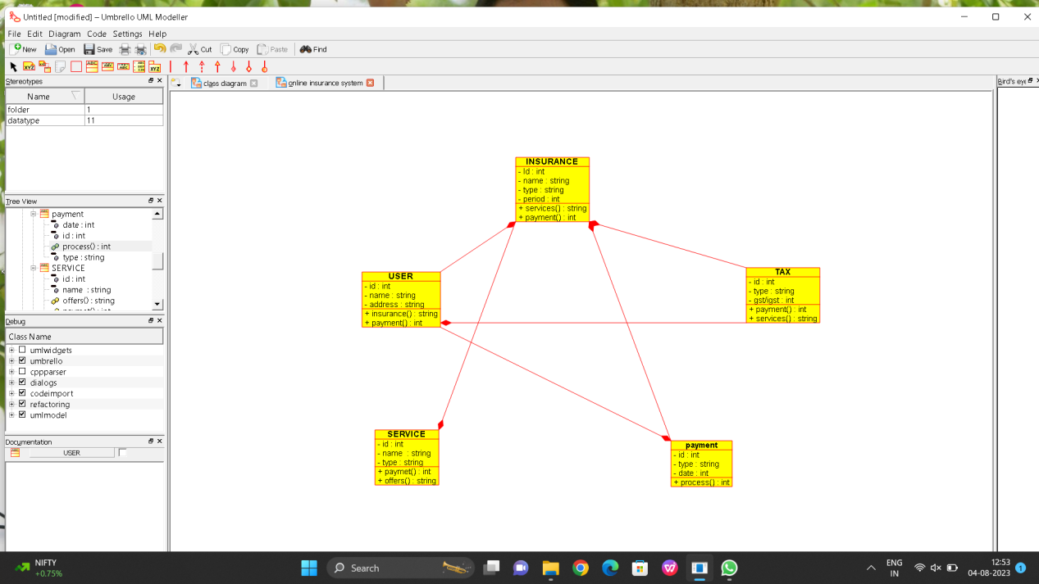

Sequence diagram:

